Name____________________________________ Homework 6.4 February 27 -March 3
Put your initials by each night that your child practiced the following:

_____ Monday _____ Tuesday _____ Thursday

*Nightly Homework*
- Count numbers 1-75.
- Review Words to Know on the newsletter.
- Study Sight Words!

a e i o u | 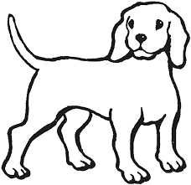 a e i o u
a e i o u | 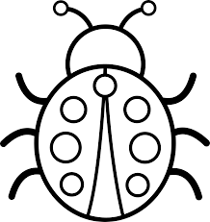 a e i o u
a e i o u | 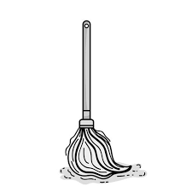 a e i o u
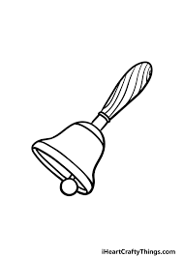 a e i o u | 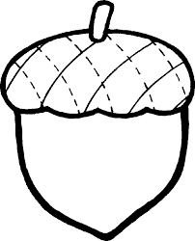 a e i o u
MONDAY: Circle the middle sound for each word.
Review the Sounds
a e i o u
sl sn sp st cl
fl u nd a st
e sp i sn o

TUESDAY-Write the correct initial consonant blend.

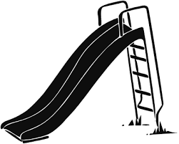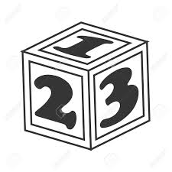

__ __oud __ __ ower __ __ide __ __ock

Read the sentence and draw a picture to illustrate.
The red van can go fast.

THURSDAY-Practice writing each spelling word three times.
tab | cob | but | leg | sip | bet | ram

Start Right Reader 6.4 Week of February 27- March 3
Directions: Let your child read this to you.

Words to Read
clip snag

stands step

Words to Know
cut must said

when went

Can Ben Get It?
“I must get that,” Ben said. Ben hops and hops. Ben stands on a step, but he can not snag it. Ben must not quit. “Got it!” said Ben. Ben got a rod. Ben fit a clip on the rod. When Ben tips the rod, the clip snags it! Ben did it! At last!

READ THE WORDS FIND THE WORD
but that get
step snag clip

last stands

